✦
HASTARA
Insights · Strengths · Path
Technical Design Document
Architecture · Data · APIs · Deployment
Document TDD-HASTARA-001 · Version 1.0
May 2026
Confidential · Engineering Reference

1. Introduction

1.1 Purpose of This Document
This Technical Design Document (TDD) describes how Hastara is built — the architecture, the components, the data, the APIs, the deployment topology, and the operational concerns. It is the engineering counterpart to the Software Requirements Specification (SRS-HASTARA-001), which defines what Hastara does. Together, the two documents form the canonical reference for any engineer joining the project.
The TDD is intentionally opinionated. Where the SRS says "the system shall support multiple AI providers", the TDD specifies OpenAI as the primary, Anthropic as the synthesis layer, Google Gemini as the fallback, with the exact failover thresholds and routing logic. Where the SRS says "the system shall be reliable", the TDD prescribes the SLO targets, the monitoring topology, and the runbooks for the on-call engineer.

1.2 Audience
- Engineers actively building Hastara (mobile, backend, web).
- SREs and DevOps engineers responsible for infrastructure, CI/CD, and on-call rotation.
- External engineering reviewers, technical advisors, and due-diligence auditors.
- New engineers joining the team — this document plus the SRS replace 80% of onboarding documentation.

1.3 Companion Documents
- SRS-HASTARA-001 — Software Requirements Specification, defines functional and non-functional requirements.
- PROJ-HASTARA-001 — Hastara Project Document, covers product vision, market analysis, and go-to-market strategy.
- RTM-HASTARA-001 — Requirements Traceability Matrix, mapping SRS requirements to TDD components and test cases.
- OPS-HASTARA-001 — Operations Runbook (separate document), incident response, on-call procedures, disaster recovery.

1.4 Architectural Principles
Five non-negotiable principles govern every design decision in this document. When two designs are equally valid, we pick the one that better satisfies more of these principles, in order:
# | Principle | What It Means in Practice
1 | Code shared by default | Every line of business logic lives in packages/, used by mobile and web. Platform-specific code in apps/ is the exception, not the default.
2 | Backend single source of truth | Subscription tier, entitlements, rate limits, and rate limits are enforced server-side. Clients render UI but cannot grant themselves access.
3 | AI cost containment | Aggressive caching, deterministic where possible, multi-provider routing. No reading is regenerated if its output is cached.
4 | Privacy by design | Palm images are treated as biometric-equivalent. RLS on every table. Encryption at rest. User-controlled deletion.
5 | Boring stack, exciting product | No bleeding-edge frameworks. React Native, Next.js, Postgres, Redis. The product's magic is in the AI synthesis and the design, not in the infrastructure choices.

2. System Overview

2.1 Multi-Platform Build Strategy
Hastara ships simultaneously to iOS, Android, and the web. The cost of this would be tripled engineering effort if naively duplicated — instead, we use a Turborepo monorepo where roughly 70% of the codebase is written once and consumed by all three surfaces. The remaining 30% (camera, gestures, server-side rendering, store-specific billing) lives in platform-specific packages.
The diagram below shows the canonical layering. User-facing clients (iOS, Android, web) consume shared packages from the monorepo; the shared packages call a single backend; the backend orchestrates AI providers, payments, and observability. This is the same pattern Linear, Cal.com, Notion, and Vercel use in production.
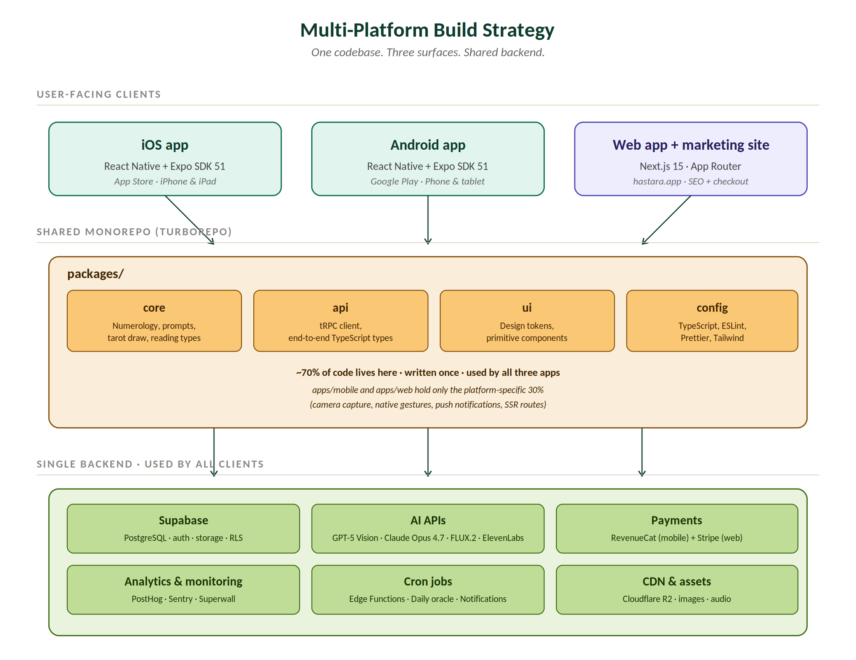
Figure 1 · Multi-Platform Build Strategy — clients, shared monorepo, single backend.

2.1.1 Why Not Pure React Native + RN-Web?
React Native Web exists and would let us ship one codebase to all three surfaces. We rejected it for two reasons. First, the marketing site (hastara.app) is the primary acquisition channel and demands first-class SEO, server-side rendering, and Lighthouse scores above 90 — none of which RN-Web delivers cleanly. Second, the in-app browsing experience on web (long-form reading display, pricing pages, blog) benefits significantly from React Server Components and Edge Runtime that Next.js 15 provides natively.
We also rejected Flutter for similar reasons — Flutter Web is improving but its SEO story remains weak, and the ecosystem of mystical/spiritual UI patterns we want to leverage (Lottie animations, Cormorant Garamond rendering, Skia-based palm contour drawing) is far richer in the React Native ecosystem.

2.1.2 Code Sharing Reality Check
A common myth in cross-platform development is "100% code sharing". The honest reality at Hastara is closer to 70% — and that's the right number. The shared parts are the parts that should be shared; the platform-specific parts are the parts that genuinely differ.
Concern | Sharing | Notes
Numerology calculations | 100% | Pure functions in packages/core. Identical on iOS, Android, web.
Zodiac & nakshatra logic | 100% | Pure functions in packages/core.
AI prompt templates | 100% | String constants and template builders in packages/core.
Tarot deck draw logic | 100% | Deterministic seeded RNG in packages/core.
TypeScript types & API client | 100% | tRPC procedures define types once; clients consume them.
Design tokens | 100% | Colors, typography scale, spacing. NativeWind on mobile, Tailwind on web — same tokens.
Primitive UI components | ~80% | Cards, buttons, layouts. Each has a .native.tsx and .web.tsx, sharing logic.
Navigation | ~50% | Different routers (expo-router vs Next.js App Router) but route structure mirrors.
Camera & palm capture | 0% | expo-camera on mobile only. Web uses upload-from-disk.
Push notifications | 0% | expo-notifications on mobile only. Web uses Web Push API.
Server-side rendering | 0% | Next.js only.
Subscription billing UI | ~30% | Branding shared; checkout flow differs (StoreKit vs Stripe Checkout).

2.2 End-to-End System Architecture
Zooming in from the monorepo view, the runtime architecture is organised into five horizontal layers. Each layer has a single responsibility, and dependencies point downward only — clients never call AI providers directly, AI providers never reach into the database. This unidirectional dependency rule is the principal reason the system is debuggable.
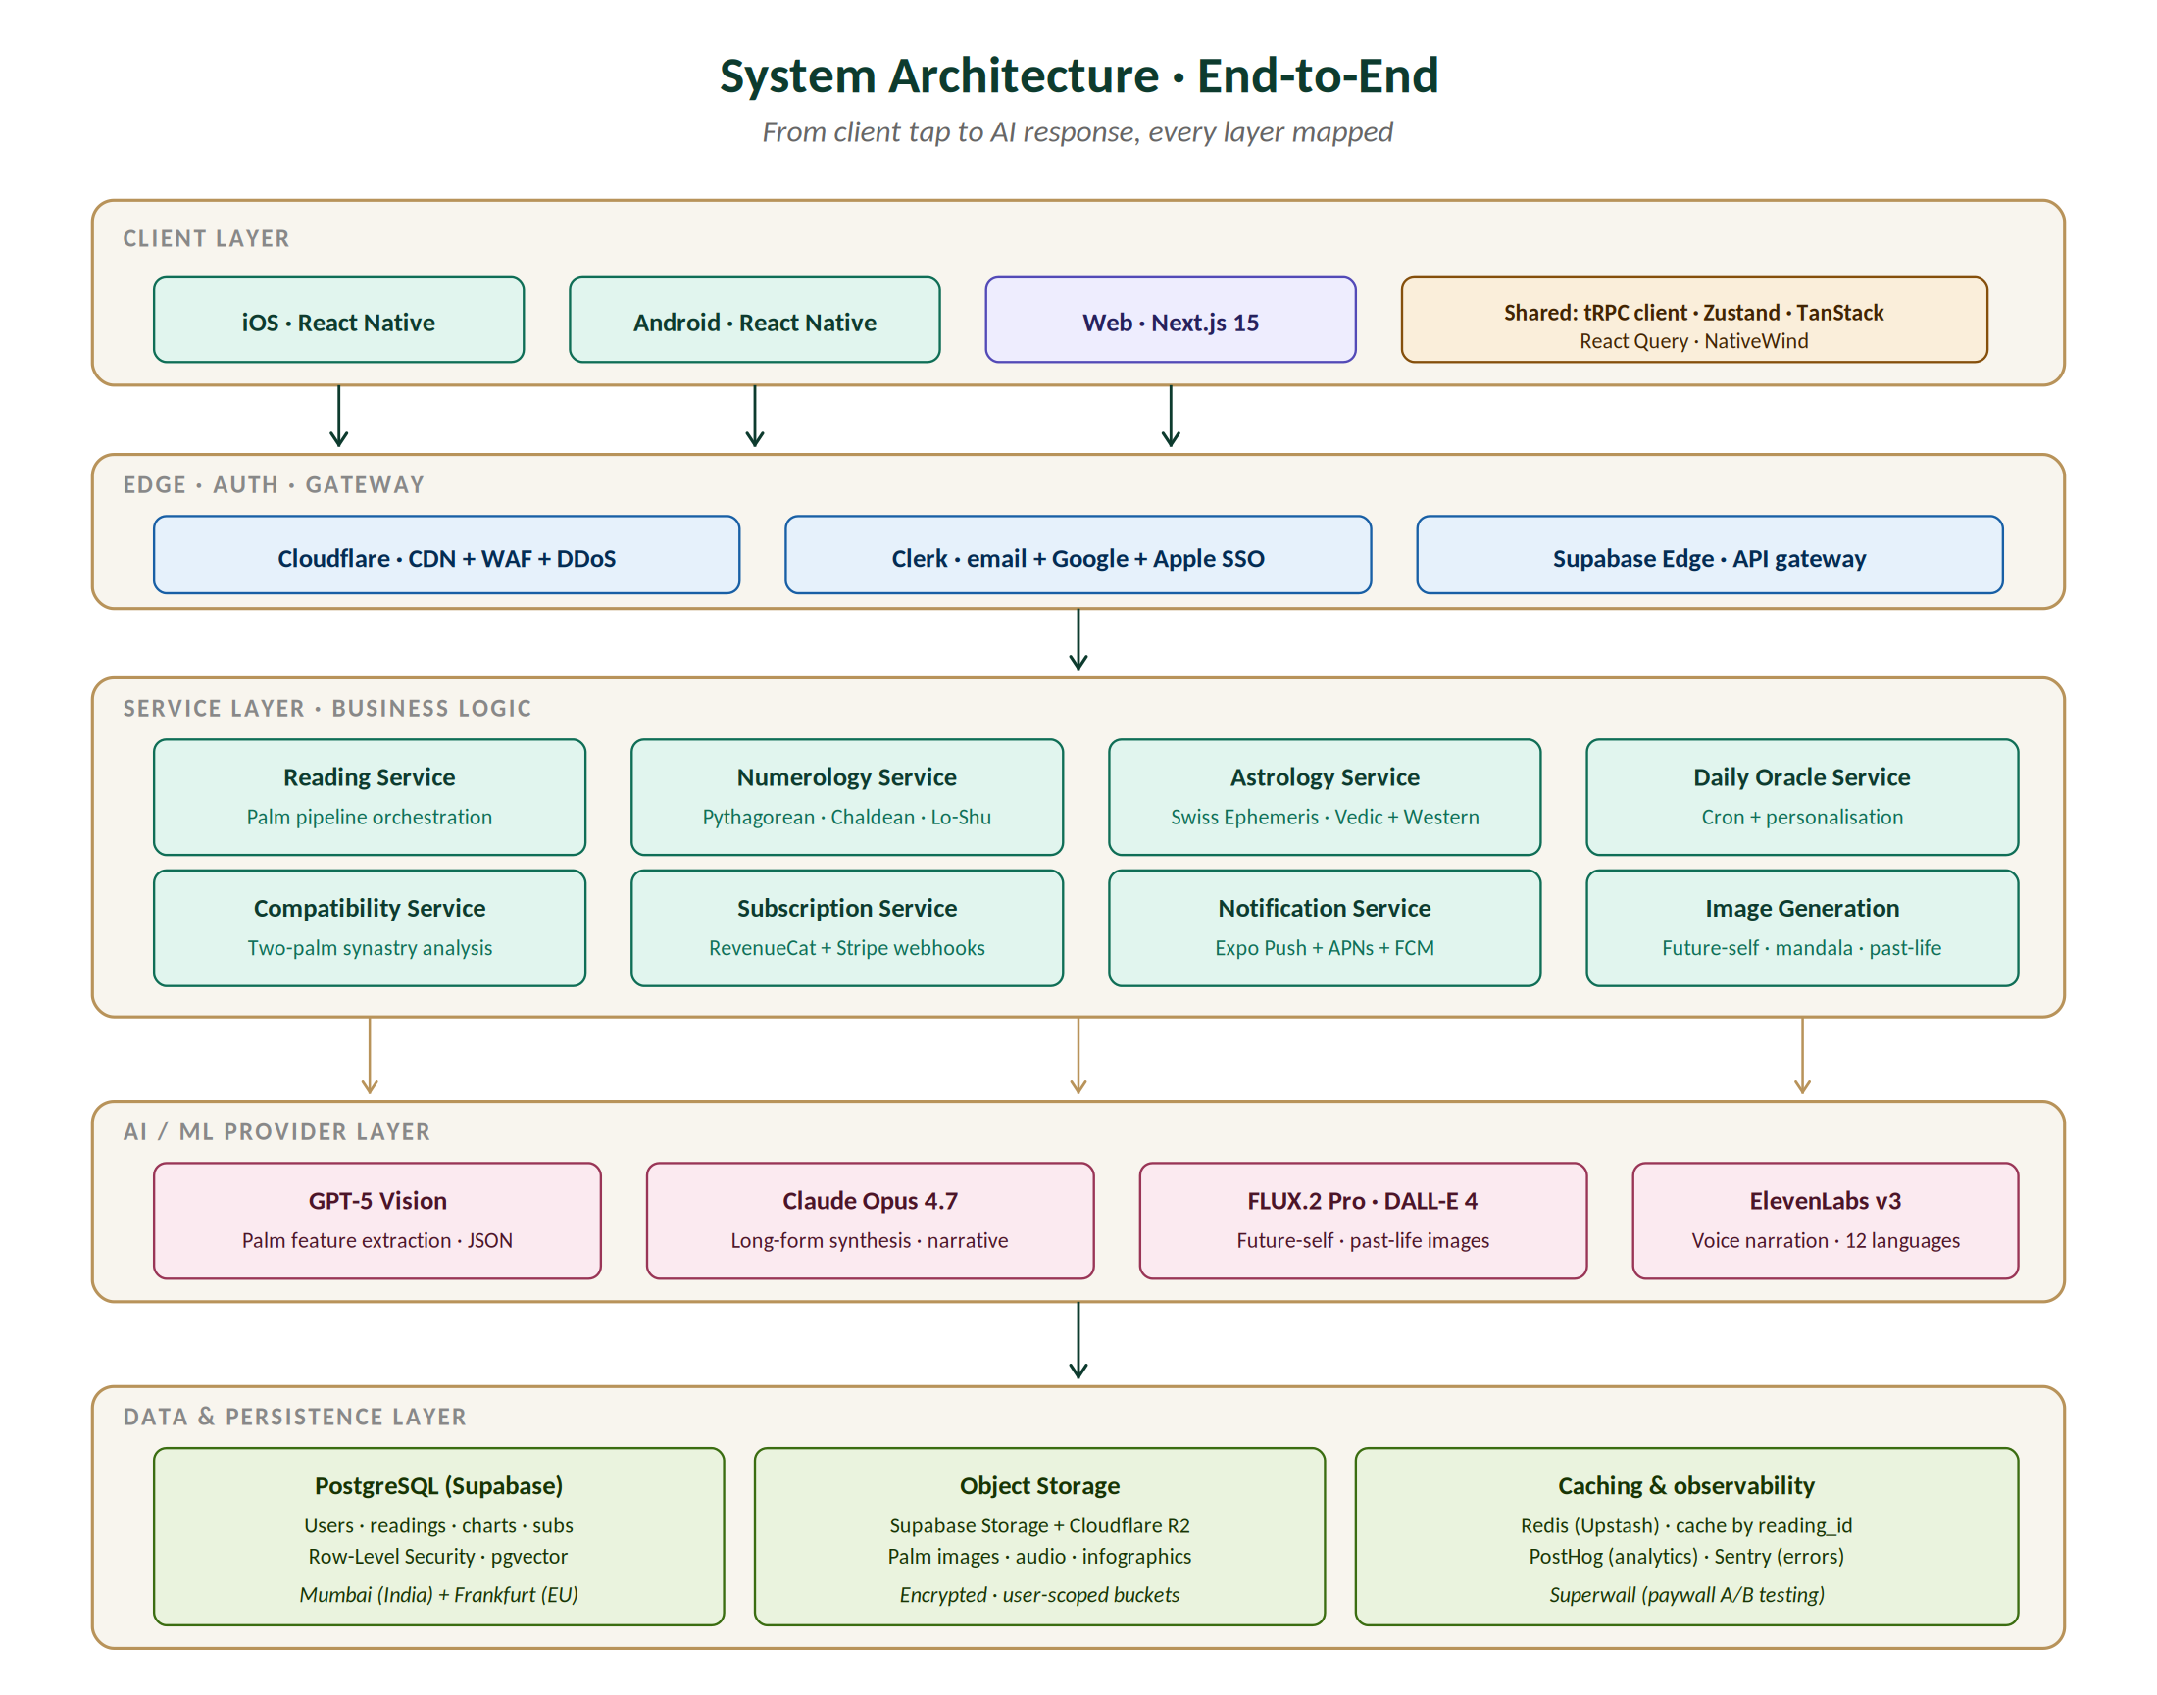
Figure 2 · End-to-End System Architecture — five layers, downward-only dependencies.

2.2.1 Layer Responsibilities
Client Layer — React Native (mobile) and Next.js (web). Owns: UI rendering, animations, camera capture, gesture handling, on-device validation. Does not own: business logic, entitlement checking, AI calls.
Edge Layer — Cloudflare CDN, WAF, DDoS protection, rate limiting. Clerk handles authentication and JWT issuance. Supabase Edge Functions act as the API gateway. Owns: traffic shaping, request validation, auth enforcement.
Service Layer — Eight stateless services running on Supabase Edge Functions: Reading, Numerology, Astrology, Daily Oracle, Compatibility, Subscription, Notification, Image Generation. Each service is independently deployable and horizontally scalable.
AI / ML Provider Layer — External APIs: OpenAI (GPT-5 Vision, DALL-E 4, embeddings), Anthropic (Claude Opus 4.7), Black Forest Labs (FLUX.2 Pro), ElevenLabs (TTS). All access is brokered through internal interfaces with multi-provider routing.
Data & Persistence Layer — PostgreSQL on Supabase (multi-region: Mumbai, Frankfurt, N. Virginia). Object storage in Supabase Storage and Cloudflare R2. Redis (Upstash) for hot caches. PostHog and Sentry for observability data.

3. Technology Stack
Every technology choice in Hastara was made deliberately, with the explicit non-goal of using anything cutting-edge. Cutting-edge tools attract attention; boring tools ship products. The exception is the AI providers themselves — there we use the best frontier model available, because that's the product.

3.1 Stack Summary
Layer | Technology | Why This Choice
Mobile framework | React Native + Expo SDK 51 | Mature, single codebase for iOS + Android, excellent OTA update story, used by Discord, Coinbase, Shopify Shop.
Mobile language | TypeScript 5.4 strict | Type safety end-to-end. No JavaScript files anywhere.
Mobile navigation | expo-router (file-based) | Mirrors Next.js conventions, one mental model across mobile + web.
Mobile styling | NativeWind v4 (Tailwind for RN) | Same Tailwind tokens as web, consistent design system enforcement.
Mobile animations | Reanimated v3 + Skia | Reanimated for gesture-driven motion, Skia for SVG-quality palm contour drawing.
Web framework | Next.js 15 (App Router) | Best SEO story, RSC, Edge Runtime, Vercel-native.
Web styling | Tailwind CSS + shadcn/ui | Same tokens as mobile, copy-paste accessible primitives.
Monorepo | Turborepo 2.x | Industry standard. Used by Vercel, Cal.com, Stripe internally.
Auth | Clerk | Managed auth with Apple/Google SSO out-of-box, Indian phone OTP support, low setup friction.
Backend runtime | Supabase Edge Functions (Deno) | TypeScript end-to-end, cold starts <100 ms, integrated with Postgres + Storage.
Database | PostgreSQL 16 (Supabase) | Industry workhorse. RLS for per-user isolation. pgvector for embeddings.
ORM | Drizzle ORM | Type-safe SQL builder, no decorator soup, plays well with Edge Runtime.
API protocol | tRPC v11 | End-to-end TypeScript types from server to client. No OpenAPI codegen needed.
Cache | Upstash Redis | Serverless Redis, pay-per-request, global replication.
Object storage | Supabase Storage + Cloudflare R2 | Supabase for user-scoped buckets; R2 for cheap, egress-free CDN.
Vision AI | OpenAI GPT-5 Vision | State-of-the-art for image understanding with structured JSON output.
Synthesis AI | Anthropic Claude Opus 4.7 | Best long-form narrative quality; tool use for chart cross-referencing.
Image generation | FLUX.2 Pro + DALL-E 4 | FLUX for portraits, DALL-E for stylised mandalas. Multi-provider safety.
Voice synthesis | ElevenLabs v3 | 12-language coverage, three voice personas, low latency.
Astronomy library | Swiss Ephemeris (via swisseph) | Gold standard for astrologers — same engine as Astro.com.
Payments (mobile) | RevenueCat + StoreKit + Play Billing | Cross-platform subscription management; webhooks for tier sync.
Payments (web) | Stripe Checkout | 3% fees vs Apple/Google's 30%. Available globally.
Push notifications | Expo Notifications + APNs/FCM | Single API across iOS and Android.
Analytics | PostHog Cloud | Self-hostable later if needed. Funnels, retention, feature flags.
Error tracking | Sentry | React Native + Next.js + Edge Functions all supported. Source maps.
Paywall A/B | Superwall | No-code paywall iteration; works with RevenueCat.
CI/CD | GitHub Actions + EAS Build + Vercel | EAS for native builds. Vercel for web. Turborepo cache speeds up CI.
CDN + WAF | Cloudflare | Best-in-class DDoS protection, R2, image transforms, Workers.

3.2 Monorepo Folder Structure
The Turborepo workspace layout maps directly to the architectural layers. The names are chosen for stability — once published, package names are stable contracts and rename costs cascade across all three applications.
hastara/
├── apps/
│ ├── mobile/ # React Native + Expo (iOS + Android)
│ │ ├── app/ # expo-router file-based routes
│ │ │ ├── (tabs)/
│ │ │ │ ├── index.tsx # Home
│ │ │ │ ├── daily.tsx
│ │ │ │ ├── history.tsx
│ │ │ │ └── profile.tsx
│ │ │ ├── reading/[id].tsx
│ │ │ ├── onboarding/
│ │ │ └── _layout.tsx
│ │ ├── components/ # mobile-only components
│ │ ├── lib/
│ │ │ ├── camera.ts # expo-camera wrapper
│ │ │ ├── notifications.ts # expo-notifications wrapper
│ │ │ └── revenuecat.ts # RevenueCat integration
│ │ ├── app.config.ts
│ │ └── package.json
│ │
│ └── web/ # Next.js 15 (App Router)
│ ├── app/
│ │ ├── (marketing)/ # SEO landing pages
│ │ ├── (app)/ # signed-in web app
│ │ ├── api/ # API routes (Stripe webhooks, etc.)
│ │ └── layout.tsx
│ ├── components/ # web-only components
│ └── package.json
│
├── packages/
│ ├── core/ # business logic — pure functions, no I/O
│ │ ├── numerology/
│ │ │ ├── pythagorean.ts
│ │ │ ├── chaldean.ts
│ │ │ └── lo-shu.ts
│ │ ├── astrology/
│ │ │ ├── zodiac.ts
│ │ │ ├── nakshatra.ts
│ │ │ └── mahadasha.ts
│ │ ├── tarot/
│ │ │ └── deck.ts # 78-card data + seeded draw
│ │ ├── prompts/ # AI prompt templates
│ │ │ ├── reading.ts
│ │ │ ├── compatibility.ts
│ │ │ └── oracle.ts
│ │ └── types/ # shared domain types
│ │
│ ├── api/ # tRPC client + types
│ │ ├── client.ts
│ │ ├── routers/ # tRPC routers (also imported by Edge Functions)
│ │ └── types.ts
│ │
│ ├── ui/ # design system primitives
│ │ ├── tokens.ts # colours, typography, spacing
│ │ ├── Card.native.tsx
│ │ ├── Card.web.tsx
│ │ └── ...
│ │
│ ├── db/ # Drizzle schema (used by Edge Functions)
│ │ ├── schema.ts
│ │ └── migrations/
│ │
│ └── config/ # shared TS, ESLint, Prettier, Tailwind
│
├── services/ # backend Edge Functions
│ ├── reading-service/
│ ├── numerology-service/
│ ├── astrology-service/
│ ├── daily-oracle-service/
│ └── ...
│
├── turbo.json
├── package.json
└── pnpm-workspace.yaml

4. AI Pipeline
The AI pipeline is the engine that converts a user's palm photograph into a personalised, multi-tradition reading. It is the most expensive part of the system per-request and the most differentiated. Every design decision here optimises for: (a) low p95 latency, (b) bounded variable cost, (c) graceful degradation under provider failure, and (d) reading quality that matches what a $200 master palmist would produce in a 90-minute session.
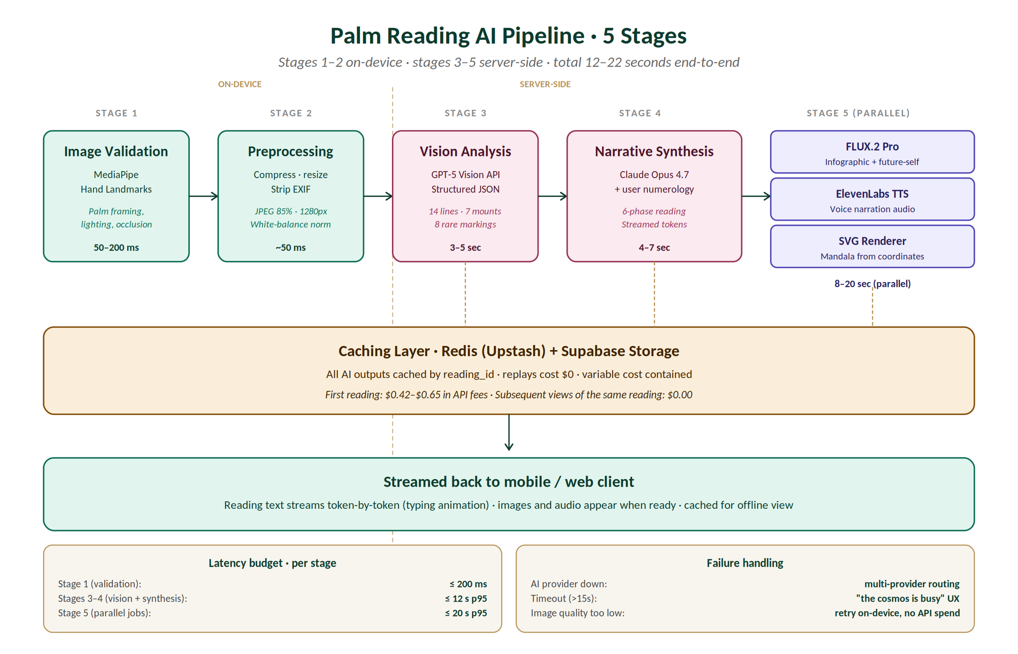
Figure 3 · AI Pipeline — five stages from on-device validation to streamed result.

4.1 Stage-by-Stage Specification

4.1.1 Stage 1 · On-Device Image Validation
The first defence against wasted API spend. Before any image leaves the device, MediaPipe Hand Landmarks (TFLite) confirms the image contains a clearly-framed palm with adequate lighting. If validation fails, the camera UI surfaces a real-time hint — "move closer", "flatten your hand", "more light" — and no upload occurs. This guards both latency and cost: a free-tier user retrying due to a poorly-framed image incurs zero server cost.
- Library: mediapipe/tasks-vision (TFLite, hand landmark model 21pt).
- Latency: 50–200 ms on iPhone 12 / Galaxy A52 reference devices.
- Acceptance criteria: 21 landmarks detected with confidence > 0.8; bounding box covers ≥ 40% of frame; pixel brightness mean within 80–200 (8-bit greyscale).

4.1.2 Stage 2 · Image Preprocessing
Once validation passes, the image is normalised before upload. JPEG compression at quality 85 strikes the right balance between file size (~600 KB target) and detail preservation needed for line analysis. Resizing to 1280px on the long edge stays well under OpenAI's 20 MB limit while preserving line clarity. EXIF data is stripped to prevent leakage of GPS coordinates or device fingerprints.
- Library: expo-image-manipulator with custom white-balance grey-world heuristic.
- Output: JPEG 85% quality, max 1280px long edge, max 1 MB, EXIF stripped, normalised white balance.

4.1.3 Stage 3 · Vision Analysis (GPT-5 Vision)
The processed image is uploaded to a user-scoped Supabase Storage bucket; the Edge Function generates a signed URL valid for 5 minutes and submits it to GPT-5 Vision with a structured JSON response schema. The system prompt forces the model to return a precise JSON document covering all 14 lines, 7 mounts, 6 fingers, hand and palm shape, and 8 rare markings. Each finding includes location coordinates (normalised 0-1), prominence rating (1-5), and observed traits (free-text array).
Latency: 3–5 seconds (p50). 12 seconds (p95). Hard timeout at 20 seconds triggers fallback.
Cost: approximately $0.18 per call at May 2026 GPT-5 pricing.
Vision system prompt (canonical)
SYSTEM:
You are an expert palmist with deep knowledge of Western chiromancy,
Vedic Hasta Samudrika Shastra, and Chinese palmistry. Analyse the
provided palm photograph and return a structured JSON response.

Return ONLY valid JSON matching this schema (no prose):

{
"hand_shape": "earth" | "air" | "water" | "fire",
"palm_shape": string,
"finger_lengths": {
"thumb": "short" | "average" | "long",
"index": "short" | "average" | "long",
"middle": "short" | "average" | "long",
"ring": "short" | "average" | "long",
"pinky": "short" | "average" | "long"
},
"thumb_flexibility": "rigid" | "moderate" | "flexible",
"lines": {
"heart": { "depth": 1-5, "length": "short"|"medium"|"long",
"shape": string, "breaks": int, "branches": int,
"traits": [string] },
"head": { ...same schema },
"life": { ...same schema },
"fate": { ...same schema, "present": boolean },
"sun": { ...same schema, "present": boolean },
"mercury": { ...same schema, "present": boolean },
"marriage": { ...same schema, "present": boolean }
},
"mounts": {
"venus": { "elevation": 1-5, "traits": [string] },
"jupiter": { ...same },
"saturn": { ...same },
"apollo": { ...same },
"mercury": { ...same },
"mars_lower": { ...same },
"mars_upper": { ...same },
"moon": { ...same }
},
"rare_markings": [
{ "type": "mystic_cross"|"ring_of_solomon"|"simian_line"|
"medical_stigmata"|"teacher_square"|"trident"|
"cross_of_st_andrew"|"star_of_apollo",
"location": string,
"confidence": 0.0-1.0 }
],
"image_quality": {
"lighting": "good"|"acceptable"|"poor",
"framing": "good"|"acceptable"|"poor",
"occlusion": "none"|"partial"|"severe"
}
}

Constraints:
- Never make medical diagnoses or fatalistic predictions.
- Frame all observations as tendencies and patterns.
- If the image quality is "poor" in any dimension, set
rare_markings to [] and reduce trait specificity.

USER: <signed image URL>

4.1.4 Stage 4 · Narrative Synthesis (Claude Opus 4.7)
The structured JSON from GPT-5 Vision, plus the user's numerology profile (life path, expression, soul urge, current personal year), plus the user's birth chart (sun, moon, rising, current Mahadasha) are passed to Claude Opus 4.7. The synthesis prompt produces the six-phase narrative reading, identifies convergence and tension nodes between the three traditions, and streams the response token-by-token to the client via Server-Sent Events.
Latency: 4–7 seconds to first token. Full reading streams over 8–12 seconds.
Cost: approximately $0.22 per call at May 2026 Anthropic pricing (Claude Opus 4.7 with ~3K input tokens, ~1.5K output tokens).

4.1.5 Stage 5 · Asset Generation (Parallel)
While the user reads the streaming narrative, three parallel jobs fire to generate supplementary assets. None of these is on the critical path — the user can interact with the reading immediately and the assets appear as they complete.
- FLUX.2 Pro: editorial infographic export (Premium+), future-self portraits (Sage). 8–18 s per asset.
- ElevenLabs v3: voice narration of the reading text, with the user's chosen voice persona. 5–12 s.
- Custom SVG renderer: soul-essence mandala generated mathematically from palm coordinates and birth chart positions. <500 ms.

4.2 Cost Containment Strategy
Without aggressive controls, a single full Sage-tier reading costs $0.42–$0.65 in API fees ($0.18 vision + $0.22 synthesis + $0.04 TTS + ~$0.10 image generation). At 100K monthly active free users averaging 2 readings each, unmanaged cost would exceed $80K/month — significantly above sustainable burn for a pre-revenue product.
Three layers of controls keep this in check:
- Caching: every AI output is keyed by reading_id and cached in Redis (hot, 7 days) plus Supabase Storage (cold, indefinite). Replays cost $0.
- Tier-based rate limiting: free tier capped at 3 readings/month enforced at the Edge Function. Mystic and above unlimited but throttled at 5/hour.
- Daily oracles batched: overnight cron generates oracles in batched API requests (10 users per call) at ~70% discount vs interactive pricing.
Cost target: ≤ $1.50/month per free user, ≤ $4.00/month per paying user. Measured weekly via OpenAI + Anthropic billing exports → Grafana dashboard. Auto-alert if any user exceeds 10× their tier baseline (signals bug or abuse).

5. Data Model
The PostgreSQL schema models eight core entities, each scoped to its owning user via Row-Level Security. The schema is designed for: (a) strict per-user isolation enforced at the database layer, (b) JSONB columns for AI outputs that don't deserve their own tables, (c) idempotent writes via natural keys where possible, (d) cheap reads for the hot paths (history list, profile screen).
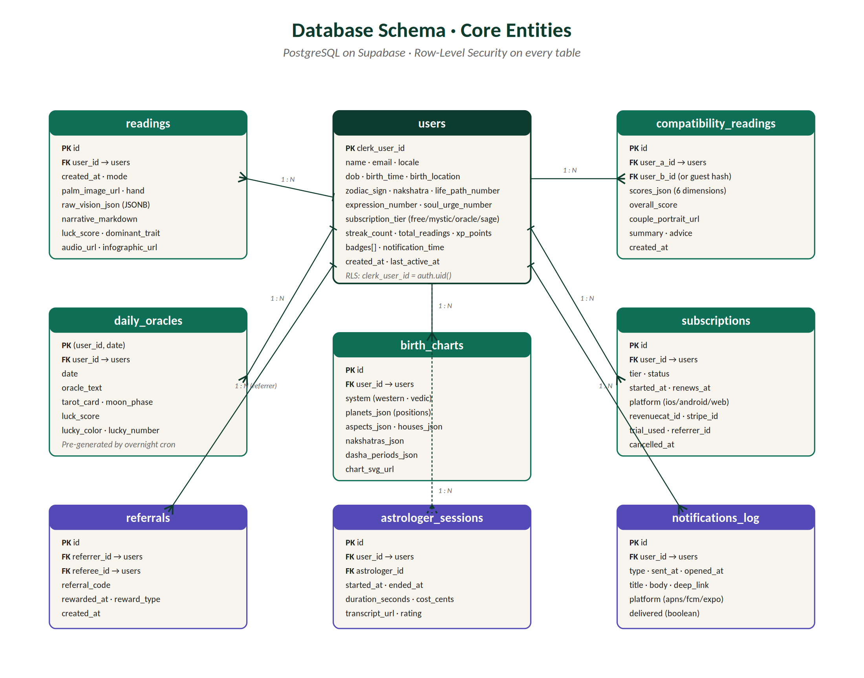
Figure 4 · Database Schema — eight core entities, all scoped by user_id with RLS.

5.1 Table Specifications

5.1.1 users
The central user record. Created on Clerk webhook (user.created event). The clerk_user_id is the primary key — we don't generate our own UUID because Clerk already provides a stable, unique, opaque identifier.
CREATE TABLE users (
clerk_user_id TEXT PRIMARY KEY,
email TEXT NOT NULL UNIQUE,
name TEXT NOT NULL,
locale TEXT NOT NULL DEFAULT 'en',
dob DATE NOT NULL,
birth_time TIME, -- nullable: optional
birth_location JSONB NOT NULL, -- { lat, lng, city, country }
dominant_hand TEXT NOT NULL CHECK (dominant_hand IN ('left', 'right')),
zodiac_sign TEXT NOT NULL, -- computed at signup
nakshatra TEXT, -- requires birth_time
life_path_number INT NOT NULL,
expression_number INT NOT NULL,
soul_urge_number INT NOT NULL,
subscription_tier TEXT NOT NULL DEFAULT 'free'
CHECK (subscription_tier IN ('free','mystic','oracle','sage')),
streak_count INT NOT NULL DEFAULT 0,
total_readings INT NOT NULL DEFAULT 0,
xp_points INT NOT NULL DEFAULT 0,
badges TEXT[] NOT NULL DEFAULT '{}',
notification_time TIME NOT NULL DEFAULT '08:00:00',
notifications_enabled BOOLEAN NOT NULL DEFAULT TRUE,
region TEXT NOT NULL, -- 'mumbai' | 'frankfurt' | 'us-east'
created_at TIMESTAMPTZ NOT NULL DEFAULT now(),
last_active_at TIMESTAMPTZ NOT NULL DEFAULT now(),
deleted_at TIMESTAMPTZ -- soft-delete; hard-delete after 30d
);

-- RLS: user can only read/write their own record
ALTER TABLE users ENABLE ROW LEVEL SECURITY;
CREATE POLICY users_self ON users
FOR ALL USING (clerk_user_id = auth.uid());

-- Indexes
CREATE INDEX idx_users_email ON users (email);
CREATE INDEX idx_users_subscription_tier ON users (subscription_tier);
CREATE INDEX idx_users_last_active_at ON users (last_active_at DESC);

5.1.2 readings
The core artefact of the application. Every palm scan creates exactly one row. raw_vision_json stores the full GPT-5 Vision JSON output verbatim — useful for re-running synthesis with different prompts later without re-scanning. narrative_markdown stores the Claude-generated 6-phase reading.
CREATE TABLE readings (
id UUID PRIMARY KEY DEFAULT gen_random_uuid(),
user_id TEXT NOT NULL REFERENCES users(clerk_user_id) ON DELETE CASCADE,
created_at TIMESTAMPTZ NOT NULL DEFAULT now(),
mode TEXT NOT NULL CHECK (mode IN
('standard','love','career','health','spiritual','crystal_ball')),
hand TEXT NOT NULL CHECK (hand IN ('left','right','both')),
palm_image_url TEXT NOT NULL,
raw_vision_json JSONB NOT NULL,
narrative_markdown TEXT NOT NULL,
luck_score SMALLINT NOT NULL CHECK (luck_score BETWEEN 0 AND 100),
dominant_trait TEXT NOT NULL,
audio_url TEXT,
infographic_url TEXT,
shared_at TIMESTAMPTZ,
vision_provider TEXT NOT NULL DEFAULT 'openai',
synthesis_provider TEXT NOT NULL DEFAULT 'anthropic',
ai_cost_cents INT NOT NULL DEFAULT 0
);

ALTER TABLE readings ENABLE ROW LEVEL SECURITY;
CREATE POLICY readings_self ON readings
FOR ALL USING (user_id = auth.uid());

CREATE INDEX idx_readings_user_created ON readings (user_id, created_at DESC);
CREATE INDEX idx_readings_mode ON readings (mode);

5.1.3 daily_oracles
Pre-generated overnight by the daily-oracle-service cron. Composite primary key (user_id, date) prevents duplicate oracles per day per user. No need to query historical oracles older than 30 days; older rows are pruned by a separate cron.
CREATE TABLE daily_oracles (
user_id TEXT NOT NULL REFERENCES users(clerk_user_id) ON DELETE CASCADE,
date DATE NOT NULL,
oracle_text TEXT NOT NULL,
tarot_card TEXT NOT NULL,
tarot_meaning TEXT NOT NULL,
moon_phase TEXT NOT NULL,
luck_score SMALLINT NOT NULL CHECK (luck_score BETWEEN 0 AND 100),
lucky_color TEXT NOT NULL,
lucky_number SMALLINT NOT NULL CHECK (lucky_number BETWEEN 1 AND 9),
generated_at TIMESTAMPTZ NOT NULL DEFAULT now(),
PRIMARY KEY (user_id, date)
);

ALTER TABLE daily_oracles ENABLE ROW LEVEL SECURITY;
CREATE POLICY oracles_self ON daily_oracles
FOR ALL USING (user_id = auth.uid());

5.1.4 birth_charts
CREATE TABLE birth_charts (
id UUID PRIMARY KEY DEFAULT gen_random_uuid(),
user_id TEXT NOT NULL REFERENCES users(clerk_user_id) ON DELETE CASCADE,
system TEXT NOT NULL CHECK (system IN ('western','vedic')),
planets_json JSONB NOT NULL,
houses_json JSONB NOT NULL,
aspects_json JSONB NOT NULL,
nakshatras_json JSONB, -- vedic only
dasha_periods_json JSONB, -- vedic only
chart_svg_url TEXT NOT NULL,
computed_at TIMESTAMPTZ NOT NULL DEFAULT now(),
UNIQUE (user_id, system)
);

5.1.5 compatibility_readings
CREATE TABLE compatibility_readings (
id UUID PRIMARY KEY DEFAULT gen_random_uuid(),
user_a_id TEXT NOT NULL REFERENCES users(clerk_user_id) ON DELETE CASCADE,
user_b_id TEXT REFERENCES users(clerk_user_id) ON DELETE SET NULL,
user_b_guest_hash TEXT, -- if partner is not registered
scores_json JSONB NOT NULL, -- six-dimension scores
overall_score SMALLINT NOT NULL CHECK (overall_score BETWEEN 0 AND 100),
couple_portrait_url TEXT,
summary TEXT NOT NULL,
advice TEXT NOT NULL,
created_at TIMESTAMPTZ NOT NULL DEFAULT now(),
CHECK (user_b_id IS NOT NULL OR user_b_guest_hash IS NOT NULL)
);

5.1.6 subscriptions
CREATE TABLE subscriptions (
id UUID PRIMARY KEY DEFAULT gen_random_uuid(),
user_id TEXT NOT NULL REFERENCES users(clerk_user_id) ON DELETE CASCADE,
tier TEXT NOT NULL CHECK (tier IN ('mystic','oracle','sage')),
status TEXT NOT NULL CHECK (status IN
('trialing','active','grace','cancelled','expired')),
platform TEXT NOT NULL CHECK (platform IN ('ios','android','web')),
revenuecat_id TEXT,
stripe_subscription_id TEXT,
trial_used BOOLEAN NOT NULL DEFAULT FALSE,
started_at TIMESTAMPTZ NOT NULL DEFAULT now(),
renews_at TIMESTAMPTZ,
cancelled_at TIMESTAMPTZ,
referrer_id TEXT REFERENCES users(clerk_user_id) ON DELETE SET NULL
);

CREATE INDEX idx_subs_user_status ON subscriptions (user_id, status);

5.2 RLS Policy Pattern
Every table follows the same Row-Level Security pattern: a single policy named <table>_self that constrains access to rows where user_id = auth.uid(). The auth.uid() function returns the authenticated user's Clerk ID, validated by the JWT signature on every request. Policies are tested as part of the integration suite — every PR that touches schema must include RLS test cases.

5.3 Data Residency
Three Postgres regions hold user data based on the region field on the users record:
- Mumbai (ap-south-1) — users with country code IN/PK/BD/LK/NP. Required for India's DPDP Act compliance.
- Frankfurt (eu-central-1) — users in EU/EEA + UK + Switzerland. Required for GDPR.
- N. Virginia (us-east-1) — all other users.
Region is determined at signup from the user's billing country (or geo-IP if no billing country is provided). Region cannot be changed later without explicit data migration. Cross-region queries are forbidden by the data layer.

6. Critical Sequence Flows
Three sequence diagrams capture the most important runtime flows. Each describes the contract between client, edge, services, and providers — including which actor is responsible for which step, and how failures propagate.

6.1 Generate a Palm Reading
The canonical happy-path. Eighteen steps from user tap to reading complete. The first 8 steps are blocking; steps 9 onward stream to the client and run in parallel where possible.
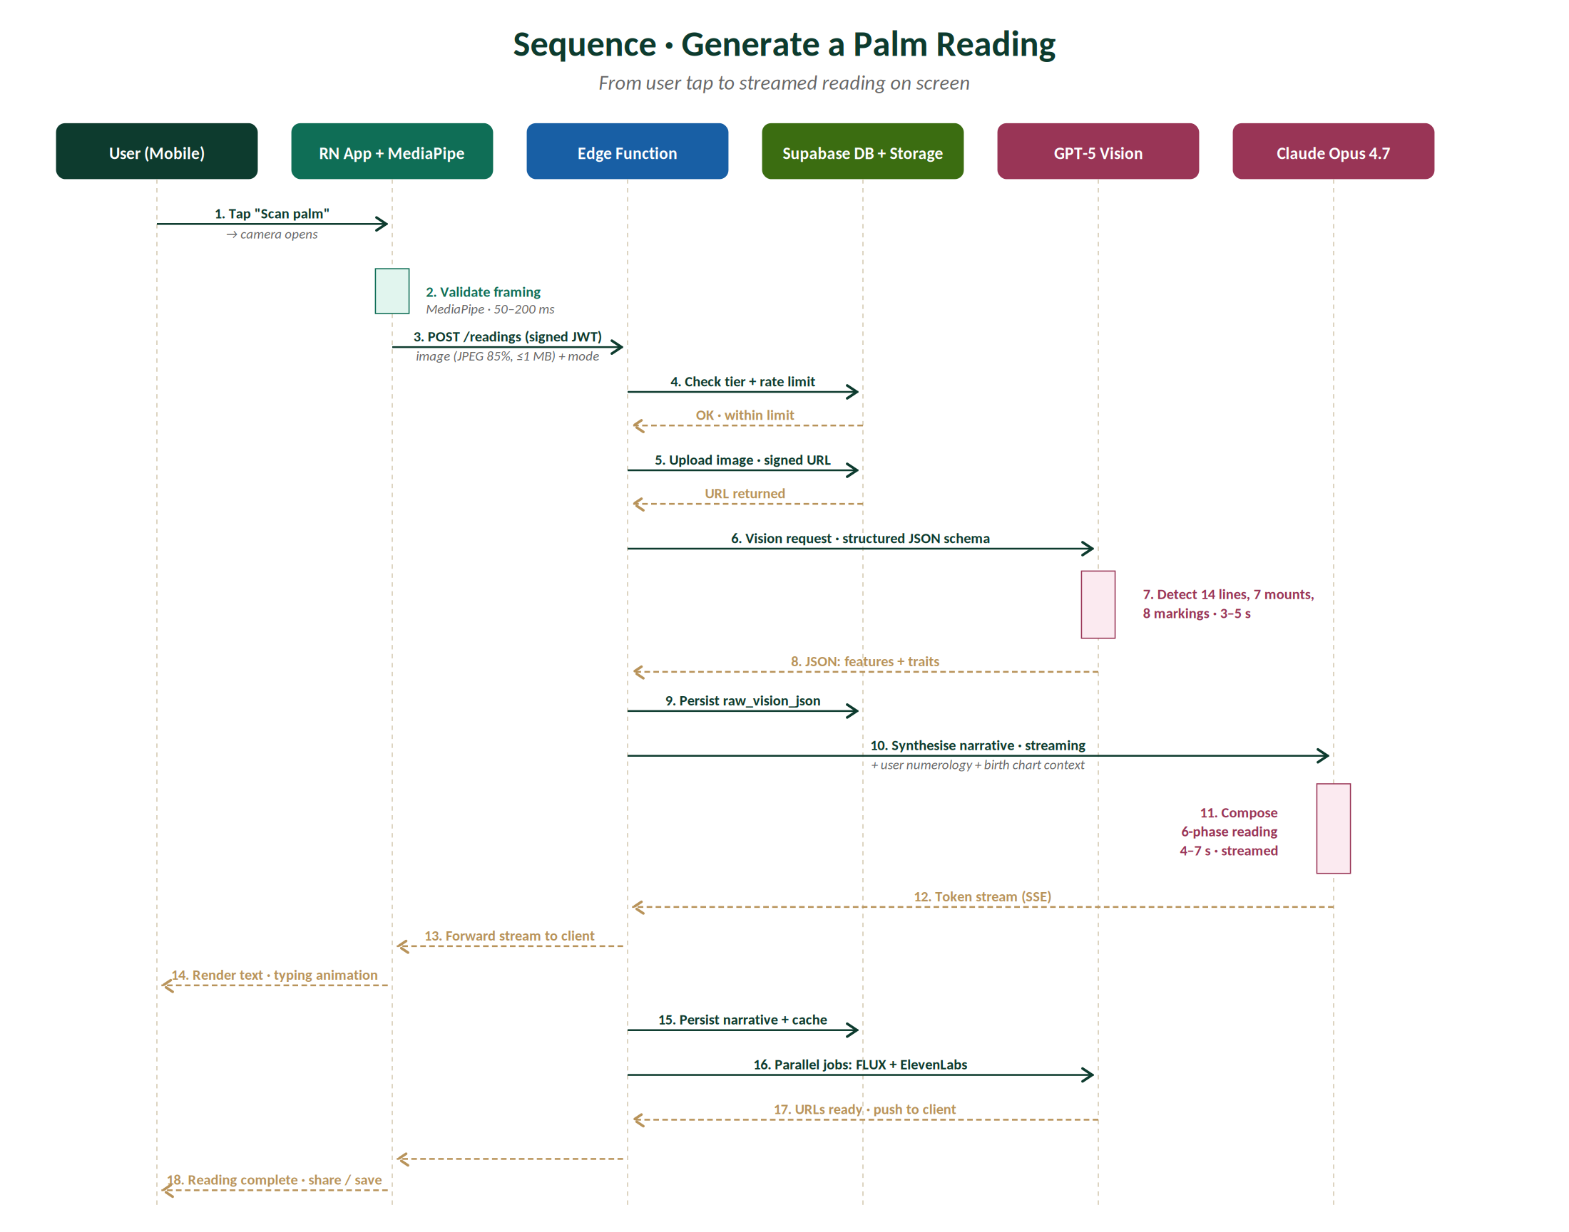
Figure 5 · Sequence — Generate a Palm Reading.

6.1.1 Step-by-Step Notes
- User taps "Scan palm" on Home tab. Camera permission has already been granted at onboarding.
- On-device MediaPipe validates framing in <200 ms. If validation fails, hint surfaces and step 1 repeats — no server round-trip.
- Image is compressed to JPEG 85% / 1280px / EXIF-stripped, then POSTed with the user's JWT and reading mode.
- Edge Function checks subscription tier and rate limits. Free tier: ≤ 3 readings this calendar month.
- If allowed, image is uploaded to user-scoped Supabase Storage bucket; signed URL valid for 5 minutes.
- Edge Function calls GPT-5 Vision with the structured-JSON system prompt and the signed URL.
- Vision API returns structured JSON in 3–5 s. Edge Function persists raw_vision_json.
- Edge Function calls Claude Opus 4.7 with vision JSON + numerology profile + birth chart context.
- Claude streams response tokens via Server-Sent Events. Edge Function forwards stream to client unchanged.
- Client renders tokens as they arrive (typing animation). User starts reading immediately.
- When stream completes, Edge Function persists narrative_markdown, luck_score, dominant_trait.
- Edge Function fires three parallel async jobs: FLUX infographic, ElevenLabs TTS, SVG mandala.
- Each parallel job updates the reading row when complete; client subscribes via Supabase Realtime.

6.2 Subscription Activation
When a user upgrades from Free to a paid tier, the flow involves the platform-store IAP system, RevenueCat, our Edge Function webhook handler, and Postgres. The critical correctness property: subscription_tier is updated on the user row only after RevenueCat confirms the receipt is valid. Until then, the user sees an optimistic spinner.
Sequence summary
- User selects tier on paywall. Client calls Apple StoreKit / Google Play Billing.
- Platform store displays native subscription confirmation (Face ID / fingerprint).
- On success, platform returns a receipt token to the client.
- Client passes receipt to RevenueCat SDK, which validates with the platform.
- RevenueCat fires a webhook to our Edge Function: subscription_started event.
- Edge Function inserts a row into subscriptions and updates users.subscription_tier.
- Edge Function calls back to the client via Supabase Realtime; client UI updates.
- Confirmation email queued via Resend.

6.3 Account Deletion
GDPR Article 17, DPDP Section 12, and CCPA Section 1798.105 all grant users the right to deletion. Hastara implements this as a 30-day soft-delete with hard-delete after the window expires. The delay protects against accidental deletions and provides time for backup rotation to flush copies.
Sequence summary
- User navigates to Profile → Privacy → Delete Account.
- Confirmation modal explains permanence; user re-authenticates.
- Edge Function sets users.deleted_at = now() and signs the user out everywhere.
- Background cron runs nightly: rows with deleted_at < now() - INTERVAL '30 days' are hard-deleted via cascade.
- Cron also purges associated palm images, audio, infographics from Supabase Storage and Cloudflare R2.
- Backup rotation continues; backups containing the user's data fully expire within 14 days of hard-delete.
- Email sent: "Your Hastara account has been permanently deleted." Includes a deletion receipt with audit trail ID.

7. API Design

7.1 tRPC Over REST
Hastara uses tRPC v11 as its primary API protocol between the Next.js / React Native client and the backend. tRPC provides end-to-end TypeScript type safety without the OpenAPI codegen step that REST or GraphQL would impose. The same procedure definitions are imported by the client and the server, with full IntelliSense in the IDE.
REST endpoints are used only where tRPC cannot reach: webhook receivers (Stripe, RevenueCat, Clerk), public marketing pages (SEO sitemap, robots.txt), and third-party integrations that expect HTTP/JSON.

7.2 Router Organisation
tRPC routers map 1:1 to the Service Layer in the architecture diagram. Each service owns one router; clients import the merged AppRouter type for full type inference.
// packages/api/src/router.ts
import { router, mergeRouters } from './trpc';
import { readingRouter } from './routers/reading';
import { numerologyRouter } from './routers/numerology';
import { astrologyRouter } from './routers/astrology';
import { dailyOracleRouter } from './routers/daily-oracle';
import { compatibilityRouter } from './routers/compatibility';
import { subscriptionRouter } from './routers/subscription';
import { profileRouter } from './routers/profile';
import { historyRouter } from './routers/history';

export const appRouter = router({
reading: readingRouter,
numerology: numerologyRouter,
astrology: astrologyRouter,
dailyOracle: dailyOracleRouter,
compatibility: compatibilityRouter,
subscription: subscriptionRouter,
profile: profileRouter,
history: historyRouter,
});

export type AppRouter = typeof appRouter;

7.3 Selected Procedure Definitions

7.3.1 reading.create
// services/reading-service/src/routers/reading.ts
import { z } from 'zod';
import { router, protectedProcedure } from '../trpc';
import { generateReading } from '../use-cases/generate-reading';

export const readingRouter = router({
create: protectedProcedure
.input(z.object({
mode: z.enum(['standard','love','career','health','spiritual','crystal_ball']),
hand: z.enum(['left','right','both']),
palmImageUrl: z.string().url(),
}))
.mutation(async ({ ctx, input }) => {
// ctx.user is injected from the JWT
return await generateReading({
userId: ctx.user.id,
mode: input.mode,
hand: input.hand,
imageUrl: input.palmImageUrl,
});
}),

list: protectedProcedure
.input(z.object({
cursor: z.string().nullish(),
limit: z.number().min(1).max(50).default(20),
}))
.query(async ({ ctx, input }) => {
// returns paginated readings for the authenticated user only
// RLS enforces user_id = auth.uid() at the DB layer
}),

byId: protectedProcedure
.input(z.object({ id: z.string().uuid() }))
.query(async ({ ctx, input }) => { /* ... */ }),

delete: protectedProcedure
.input(z.object({ id: z.string().uuid() }))
.mutation(async ({ ctx, input }) => {
// soft-delete; storage purge runs nightly
}),
});

7.3.2 dailyOracle.today
export const dailyOracleRouter = router({
today: protectedProcedure
.query(async ({ ctx }) => {
// 1. Look up user's pre-generated oracle for today (overnight cron)
// 2. If missing (rare), generate on-demand and cache
// 3. Return: { oracleText, tarotCard, tarotMeaning, moonPhase,
// luckScore, luckyColor, luckyNumber }
}),

history: protectedProcedure
.input(z.object({ limit: z.number().max(30).default(7) }))
.query(async ({ ctx, input }) => { /* last N days */ }),
});

7.4 Webhook Endpoints (REST)
Endpoint | Provider | Purpose
POST /webhooks/clerk | Clerk | user.created → insert into users; user.deleted → soft-delete.
POST /webhooks/revenuecat | RevenueCat | Subscription lifecycle events (started, renewed, cancelled, refunded, trial_converted).
POST /webhooks/stripe | Stripe | Web subscription events. Same lifecycle as RevenueCat but for web purchases.
POST /webhooks/sentry | Sentry | Critical error alerts route to PagerDuty via this endpoint for filtered escalation.

7.5 Authentication & Authorisation
Every tRPC procedure is protectedProcedure unless explicitly public (e.g. astrologer marketplace listing for unauthenticated browsing). The protected middleware:
- Reads the Authorization: Bearer <jwt> header.
- Verifies the JWT signature against Clerk's JWKS endpoint (cached 1 hour).
- Extracts user_id from the JWT claims.
- Looks up the user row to attach subscription_tier and other context.
- Throws TRPCError with code UNAUTHORIZED if any step fails.
- Throws FORBIDDEN if the user's tier is insufficient for the procedure.

7.6 Rate Limiting
Two layers of rate limiting protect the system: edge-level (Cloudflare WAF rules) and application-level (Upstash Redis token-bucket via the @upstash/ratelimit library).
Endpoint pattern | Free | Mystic+ | Window
reading.create | 3 | unlimited* | calendar month
reading.create (burst) | 1 | 5 | per hour
compatibility.create | 0 | 10 | calendar month
dailyOracle.today | 20 | 100 | per hour
profile.update | 5 | 20 | per minute
Any read query | 60 | 120 | per minute

*"Unlimited" for paid tiers means "no monthly cap" but is still subject to the 5-per-hour burst limit. This protects against accidental client-side loops and abuse.

8. Security & Privacy Architecture

8.1 Threat Model
Hastara holds three classes of sensitive data: palm photographs (treated as biometric-equivalent), birth-time and birth-location (PII, useful for identity-targeting), and AI-generated content tied to a real person's identity. The threat model focuses on five attack vectors:
Threat | Severity | Mitigation
Database breach (mass PII exfiltration) | Critical | AES-256 at rest with KMS-managed keys. RLS prevents lateral access. Read replicas have no write credentials. Annual pen-test.
Account takeover (credential stuffing) | High | Clerk handles auth — bot detection, breach-DB checks. Suspicious-login email alerts. Session listing in app.
Cross-user data leak (RLS bypass) | High | RLS policies tested in CI on every PR touching schema. No direct DB access from clients. Edge Functions use service role only for admin operations.
AI prompt injection / jailbreak | Medium | System prompts include guardrails against medical, fatalistic, financial advice. Output post-filter via OpenAI Moderation API. Quarterly red-team exercise.
Image scraping (palm-image leak) | High | Storage buckets are private. URLs are signed and expire in 5 min. Image transforms via Cloudflare Workers without exposing direct storage URLs.
Webhook spoofing | Medium | All webhooks verify HMAC signatures (Clerk, Stripe, RevenueCat). Replay protection via timestamp + nonce.
Subscription-tier escalation | Medium | Tier check happens server-side on every protected procedure. Clients cannot grant themselves access by editing local state.

8.2 Encryption Strategy
- In transit: TLS 1.3 minimum. HSTS preloaded. Certificate pinning on mobile via Expo SSL pinning library.
- At rest (database): AES-256-GCM. Keys managed in AWS KMS, rotated every 90 days.
- At rest (object storage): Server-side encryption with customer-managed keys (SSE-CMK). Cloudflare R2 uses XChaCha20-Poly1305.
- Application-layer: birth_location is stored in plaintext (queried frequently). Phone numbers (where used) are hashed with bcrypt before storage.

8.3 Privacy Engineering
We treat palm photographs as biometric-equivalent even though they are not formally classified as biometric data under most current statutes. This conservative posture protects users and pre-empts regulatory shift.

8.3.1 Data Minimisation
- Palm images are deleted from object storage 90 days after the reading is generated, unless the user pins them. The structured JSON output is preserved (it does not contain the photograph).
- Birth time and location are required only for Vedic chart calculation. Users can opt out of full Vedic and use Sun-only mode without providing exact time.
- No third-party advertising trackers in the app or on the web. Analytics is first-party (PostHog self-hosted long-term) with IP anonymisation.

8.3.2 User Rights
- Right to access: Profile → Privacy → Export My Data generates a JSON archive within 24 hours.
- Right to deletion: Profile → Privacy → Delete Account triggers 30-day soft-delete then hard-delete with audit trail.
- Right to rectification: Profile → Settings allows editing all profile fields. Numerology/astrology recomputes automatically.
- Right to portability: Export format is structured JSON, machine-readable, containing all readings and charts.

8.4 Compliance Framework
Regulation | Status | Evidence
GDPR (EU/EEA) | Compliant at launch | DPIA conducted. Data Processing Addendum with all sub-processors. EU representative appointed.
CCPA/CPRA (California) | Compliant at launch | "Do Not Sell" toggle. Privacy policy section in plain English.
DPDP Act 2023 (India) | Compliant at launch | Consent-first onboarding. Mumbai data residency. Indian DPO appointed.
COPPA (US under-13) | Compliant at launch | Minimum age 13 enforced. DOB gating at signup.
Illinois BIPA / Texas CUBI | Defensive posture | Explicit "we do not extract biometric templates" disclosure. Storage policy documented.
SOC 2 Type II | Target: 12 months post-launch | Audit firm engaged. Initial controls implemented at launch.
ISO/IEC 27001 | Target: 18 months post-launch | Will be pursued after SOC 2 if enterprise customers materialise.

9. Deployment & DevOps
The deployment topology supports three platforms (iOS, Android, web) with three different release cadences (App Store ~weekly, Play Store ~daily, web continuous). The CI/CD pipeline is unified at the source (GitHub Actions) but branches into platform-specific build systems (EAS for mobile, Vercel for web).
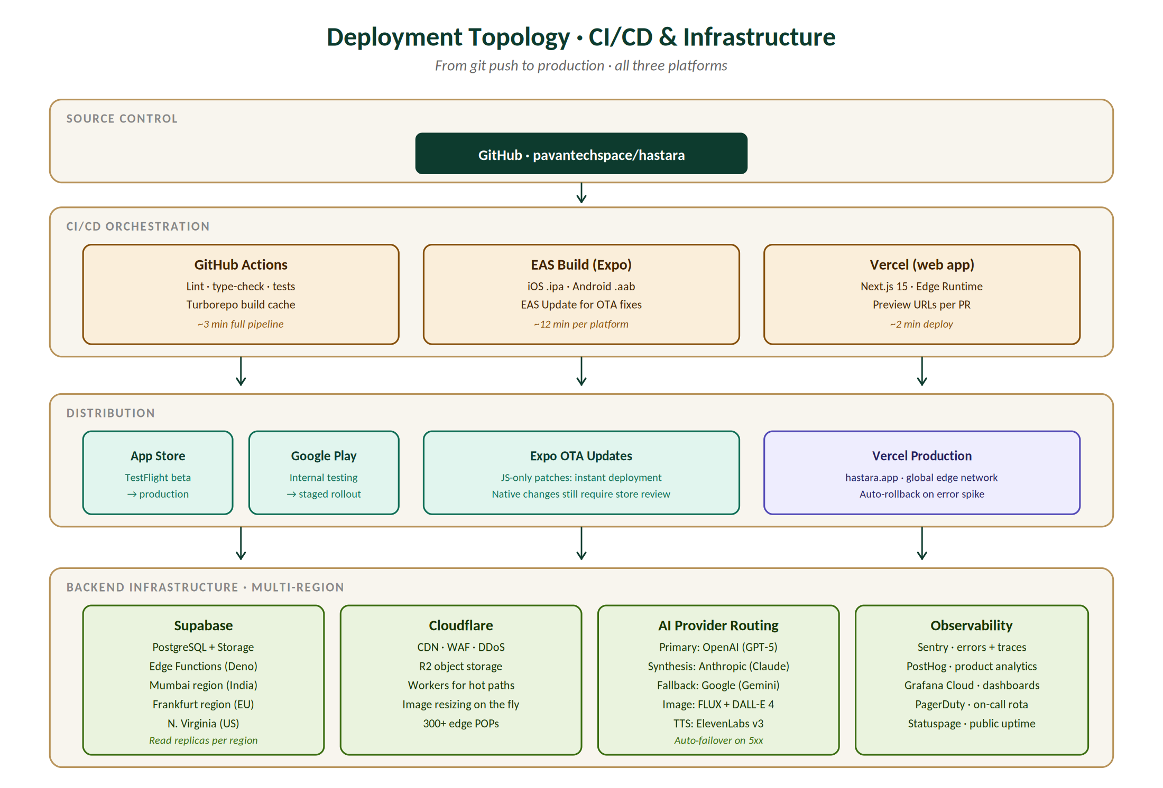
Figure 6 · Deployment Topology — from git push to production across three platforms.

9.1 Build & Release Pipelines

9.1.1 Mobile (iOS + Android)
Mobile builds use Expo Application Services (EAS) Build. A push to main triggers a parallel build for both platforms; the resulting artefacts (.ipa for iOS, .aab for Android) are submitted to TestFlight and Internal Testing automatically. Production rollout is manual (a human decision), staged at 10% → 50% → 100% over 7 days.

9.1.2 Mobile OTA (Expo Updates)
JavaScript-only changes ship via Expo Updates (over-the-air) within minutes, bypassing store review. Native code changes (new Expo SDK version, new native modules) still require a full store submission. The OTA channel is locked to the matching native binary version to prevent compatibility issues.

9.1.3 Web (Vercel)
Every PR creates a preview URL on Vercel. Merging to main deploys to production within 2 minutes. Vercel's Edge Runtime serves dynamic routes from the closest of 19 global regions. Static marketing pages are pre-rendered at build time and served from the CDN.

9.2 Environments
Environment | Domain | Database | Used For
Local | localhost | Local Postgres (Docker) | Day-to-day engineering work.
Preview | hastara-pr-[N].vercel.app | Branch-specific Supabase shadow | PR review, design review, automated E2E tests.
Staging | staging.hastara.app | Staging Supabase project | Pre-release QA, integration testing, partner demos.
Production | hastara.app | Multi-region Supabase production | End users.

9.3 Feature Flags & Gradual Rollouts
All new features ship behind PostHog feature flags. The default rollout pattern is: 1% → 10% → 50% → 100% over 7 days, with automatic rollback if Sentry error rate spikes >1% above baseline or if PostHog conversion drops >5%. This applies to AI prompt changes too — prompts are versioned, A/B tested, and promoted only after measurable improvement.

9.4 Disaster Recovery
Scenario | Recovery Action | Target RTO
Vercel outage (web down) | DNS fails over to Cloudflare static fallback page; mobile apps unaffected. | < 5 min
Supabase region outage | DNS routes to nearest healthy region with read-only mode until primary returns. | < 30 min
Database corruption | Point-in-time restore from continuous backups (last 7 days). | < 1 hour
AI provider sustained outage | Auto-failover to backup provider; degraded reading quality but service continues. | < 3 sec
Stripe / RevenueCat outage | Subscriptions in flight queued for retry; existing entitlements unaffected. | auto-recovery
Cloudflare full outage | Origin servers exposed via fallback DNS; degraded but functional. | < 10 min

9.5 Observability

9.5.1 The Three Pillars
- Metrics: Grafana Cloud dashboards aggregating Postgres, Edge Function, AI provider, Stripe, and RevenueCat metrics. SLO dashboards per service.
- Logs: Structured JSON logs from every service, correlated by trace ID, retained 30 days in Grafana Loki.
- Traces: OpenTelemetry traces from edge through services through AI providers, sampled at 10% normally, 100% on errors.

9.5.2 SLOs
Service / Surface | SLO | Error Budget
Reading service availability | 99.5% / month | 3.65 hours / month
Reading p95 latency | < 12 s end-to-end | 5% requests > 12 s
Daily Oracle availability | 99.9% / month | 43 min / month
Subscription webhook processing | 99.95% / month | 21 min / month
App crash-free user rate | 99.5% | 0.5% crash rate
Database p95 query latency | < 100 ms | 5% queries > 100 ms

10. Performance & Scalability

10.1 Capacity Plan
The system is designed to scale from launch (5K daily active users at month 1) to 200K daily active users at month 18 without architectural rewrites. The key scalability levers are stateless Edge Functions (horizontal scale by request volume), read replicas (handle history list reads), Redis caching (offload hot AI outputs), and AI provider fan-out (multi-provider routing balances load).
Metric | M1 Launch | M6 | M18 Target | M36 Stretch
DAU | 5K | 60K | 200K | 500K
MAU | 25K | 300K | 1M | 2.5M
Readings / day | 8K | 120K | 450K | 1.2M
DB rows (readings) | 240K | 3.6M | 13M | 36M
Storage (palm + audio) | ~20 GB | ~300 GB | ~1.1 TB | ~3 TB
AI cost / month | $2K | $22K | $72K | $180K
Postgres tier | Pro $25/mo | Team $599 | Enterprise | Multi-region+

10.2 Latency Budget
Every screen has a target time-to-interactive. Budgets are enforced via synthetic tests in CI; PRs that regress p95 latency by more than 10% are auto-flagged for review.
Surface / Action | p50 | p95 | Notes
App cold start (mobile) | 1.5 s | 2.5 s | Hermes engine + Reanimated worklets warmed.
Home tab first paint | 500 ms | 1.0 s | Pre-fetched on app launch.
Reading first token | 5 s | 12 s | Vision call + Claude TTFT.
Reading complete (text) | 12 s | 22 s | Claude streaming complete.
Daily Oracle render | 300 ms | 700 ms | Pre-generated overnight.
History list (20 items) | 200 ms | 500 ms | Indexed query.
Subscription paywall | 400 ms | 900 ms | Superwall pre-fetch.
Web Lighthouse perf score | 90+ | 85+ | Marketing pages SSR + CDN.

10.3 Caching Strategy
Resource | Layer | TTL | Invalidation
Reading narrative | Postgres + Redis | indefinite | Manual: user deletes reading.
AI vision JSON | Postgres | indefinite | Same as reading.
Daily oracle | Postgres | 24 hours | Cron rotation at midnight.
User profile | Redis | 15 min | On profile update.
Subscription tier | Redis | 5 min | On webhook event.
Birth chart SVG | Cloudflare CDN | 1 year | On profile DOB/time edit.
Marketing pages | Vercel ISR | 1 hour | On content change in CMS.
Astrologer listing | Redis | 5 min | On astrologer status change.

11. Testing Strategy

11.1 Test Pyramid
We follow the classic pyramid: many unit tests, fewer integration tests, fewest E2E tests. The investment ratio is roughly 70 / 25 / 5. Unit tests run in milliseconds and gate every PR; E2E tests run nightly and gate releases.
Layer | Tooling | Coverage Target | Run Frequency
Unit | Vitest + Testing Library | 70% lines / 60% branches | Every PR (CI)
Integration | Vitest + Testcontainers | All API procedures | Every PR (CI)
Contract | Pact | All AI provider boundaries | Nightly
E2E (mobile) | Maestro | Top 12 user journeys | Nightly + pre-release
E2E (web) | Playwright | Top 8 user journeys | Every PR (CI)
Visual regression | Chromatic | All UI components | Every PR (CI)
Load | k6 | Critical endpoints | Pre-release
Penetration | External firm | Full system | Annual + major release

11.2 AI Quality Testing
AI outputs cannot be unit-tested in the traditional sense — they're non-deterministic and the "correct" answer is a judgement call. We use three complementary techniques:
- Structural validation: every AI output is parsed against its expected JSON schema. Schema violations fail fast and trigger retries.
- LLM-as-judge: a separate Claude instance grades each reading on rubrics (specificity, no medical claims, no fatalism, tone match). Scores below threshold trigger human review.
- Human eval panel: a panel of 5 traditional palmists reviews 100 readings per quarter. Their feedback drives prompt iterations.

11.3 Cultural Authenticity Testing
Vedic content carries higher consequences for misrepresentation than Western content. Every prompt change touching Hindi, Sanskrit, Vedic astrology, or Hasta Samudrika Shastra is reviewed by our credentialed Vedic palmistry consultant before release. The consultant also reviews user-reported "this doesn't feel right" tickets weekly.

12. Technical Risks & Mitigations
Risk | Likelihood | Impact | Mitigation
AI provider price doubles overnight | Medium | High | Multi-provider routing already designed in. Cost dashboards alert on spike. Quarterly contract reviews with all providers.
Apple App Store rejection (fortune content) | Medium | Critical | Pre-submission review through Apple developer relations. "Lifestyle" category. Mandatory disclaimer copy. Backup plan: web-first launch.
Postgres region outage during launch | Low | High | Multi-region deployment with automated failover. Read replicas in N+1 regions. DR drills quarterly.
Camera permission denial blocking key flow | Medium | Medium | Upload-from-gallery alternative always available. Onboarding messaging emphasises why camera is needed.
Expo SDK breaking change in major upgrade | High annual | Medium | Lock to specific SDK versions. Test on canary track for one full release cycle before production.
React Native New Architecture migration | Medium | Medium | Plan migration during a low-traffic quarter. Dual-build period for safety.
MediaPipe TFLite model size grows native binary | Low | Low | Use compressed model variant. Ship model via Expo Updates rather than bundling.
Scaling DB beyond Supabase Enterprise tier | Low (year 1-2) | High (year 3+) | Architecture supports migration to AWS RDS Multi-AZ. Drizzle ORM portable.
AI hallucinations producing harmful content | Medium | High | System prompt guardrails + output content filter + LLM-judge + human review queue for flagged outputs.
Vendor lock-in (Supabase, Vercel) | Low | Medium | All vendor APIs wrapped behind internal interfaces. Postgres + Next.js are open standards. Migration paths documented.

Appendix A · Reference Material

A.1 Component Sizing
At v1.0 launch, the system runs at the following capacity. These numbers are confirmed via load testing in staging and conservative for the first 6 months.
Component | Capacity | Cost (M1)
Supabase Pro | 8 GB DB, 100 GB storage | $25/mo
Cloudflare R2 + Workers | 500 GB, 10M requests | $15/mo
Vercel Pro | Web app + edge functions | $20/mo
Upstash Redis | 256 MB hot cache | $10/mo
Clerk Pro | Up to 10K MAUs included | $25/mo + $0.02/MAU
RevenueCat Starter | Up to $2.5K MTR free | $0 → $299 at threshold
OpenAI + Anthropic | Burn-rate dependent | $2K/mo target
Sentry + PostHog + Grafana | Standard tiers | $120/mo
Total infra (M1) | — | ~$2,200/mo

A.2 Open Questions
The following items are unresolved at the time of this TDD draft and require decisions before launch:
- Q1: Should we use Hermes JS engine on iOS (currently default on Android)? Pro: faster cold start. Con: smaller community of debugging tools.
- Q2: Build internal "user impersonation" tool for support? Risk: new attack surface. Reward: faster customer support resolution.
- Q3: On-device hand landmark inference vs server-side? Currently leaning on-device for privacy + cost. Need to confirm Android low-end devices can run TFLite at 30 FPS.
- Q4: Drizzle ORM vs Kysely? Both are excellent. Drizzle has better DX in Edge Functions; Kysely has better community in 2026. Pick by week 2.

A.3 Glossary
Term | Definition
Edge Function | Stateless TypeScript function running on Supabase Edge (Deno). Cold start <100 ms. Used for all backend logic.
EAS Build | Expo Application Services build platform. Compiles React Native + Expo source into native iOS .ipa and Android .aab.
EAS Update | Expo's OTA update mechanism. Ships JavaScript-only patches without store review.
Drizzle ORM | TypeScript-first SQL builder. Generates type-safe queries from a schema definition.
tRPC | TypeScript-first RPC framework. Procedures defined server-side gain client types automatically. Replaces REST/GraphQL for our internal API.
NativeWind | Tailwind CSS implementation for React Native. Same class names as web Tailwind.
RLS (Row-Level Security) | Postgres feature where row visibility is restricted by per-user policies. Enforced at the DB layer, not app layer.
SSE (Server-Sent Events) | HTTP streaming protocol where the server pushes events to the client. Used for streaming AI reading text.
Superwall | No-code paywall A/B testing platform. Used to iterate on paywall design without app submissions.
Triple Convergence | Hastara's proprietary cross-system synthesis engine. Reconciles palmistry, numerology, and Vedic astrology findings.

✦
End of Technical Design Document
Document TDD-HASTARA-001 · Version 1.0 · May 2026

